Shuna Scott Sendall Soprano 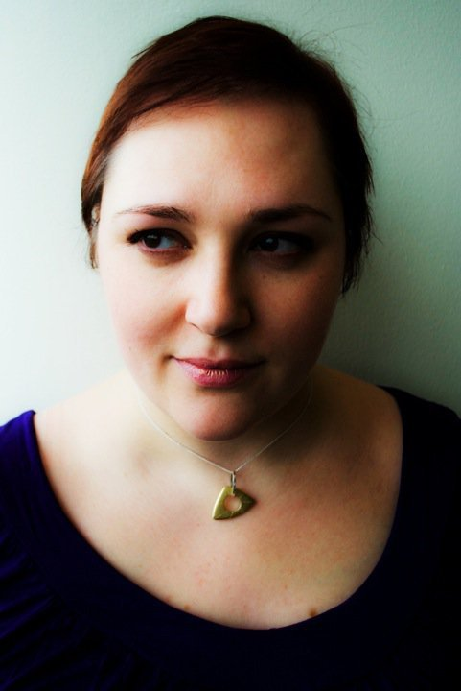
NATIONALITY

Scottish

FUTURE PLANS

2011 Das Paradies und die Peri, Peri, Glasgow University with Scottish Opera Orchestra
Clemenza Di Tito, Vitellia (cover), ETO
Gianni Schicchi, La Ciesca (cover), ETO
Fantastic Mr Fox, Mrs Fox (cover), ETO
Friday Night is Music Night, BBC Concert Orchestra, Radio 2
Opera Gala Recitals for ETO
Big Red Nose Show, Royal Albert Hall, Radio 3
Recitals at Les Heures Musicales d’Aujols
Accademia Solti Te Kanawa

ROLES/CHORUS

2010 Hansel and Gretel, Mother/Witch, Dorset Productions
Carmen, Frasquita (cover), Dorset Opera
Die Meistersinger, Ensemble, WNO
La Boheme, Ensemble, Scottish Opera

2009 Lohengrin, Elsa (cover), The Mastersingers
Cavalleria Rusticana, Santuzza (cover), Dorset Opera
L’Elisir d’Amore, Ensemble, Scottish Opera
Manon, Ensemble, Scottish Opera
I Puritani, Ensemble, Scottish Opera

2008 Secret Marriage, Housekeeper, Scottish Opera
La Traviata, Ensemble, Scottish Opera
Two Widows, Ensemble, Scottish Opera
Falstaff, Ensemble, Scottish Opera

2007 Die Meistersinger, Magdalene, Edinburgh Opera Players
Madama Butterfly, The Aunt, Scottish Opera
Lucia di Lammermoor, Ensemble, Scottish Opera

2006 The Bartered Bride, Ensemble, Mid Wales Opera
Carmen, Ensemble, Scottish Opera

2005 Carmen, Carmen, Cupar Choral Society
Carmen, Carmen (cover), Haddo House Operatic Society
Carmen, Micaela, Haddo House Operatic Society
Carmen, Ensemble, Mid Wales Opera

2004 The Minotaur, Medea, Scottish Opera
Cunning Little Vixen, Cock, Jay, Innkeepers wife, BYO

2003 Idomeneo, Elettra, RSAMD
L’heure, Espagnole, Concepcion, RSAMD

2002 Gianni Schicchi, La Ciesca, RSAMD
La Callisto, Furie, RSAMD

1999 Down by the Greenwood Side, Mrs Green, RSAMD
Albert Herring, Lady Billows (cover), RSAMD

EDUCATION (all at RSAMD)

2003 Mopera
2002 Mmus Opera
1999 Mmus Concert Singer
1998 CPGS Concert Singer
1997 DRSAMD Performance

AWARDS

2011 Finalist Bayreuth Bursary
2010 Winner BBC Radio 2 Kiri Prize
2009 Finalist Bayreuth Bursary
2004 Winner Scottish Wagner Society Bayreuth Bursary
2003 Winner Great Elm Vocal Awards
2002 Winner Margaret Dick Award
Winner Ramsey A Calder Debussy Prize
Winner RSAMD Governers Recital Prize
Winner Bill Dewar Memorial Prize
2001 Winner David Frame Memorial Prize
1998 Winner Hugh S Roberton Scots Song Prize

Scottish soprano Shuna Scott Sendall graduated from the Alexander Gibson Opera School at RSAMD, where she studied with Jane Irwin and Patricia Macmahon. She is a Samling Scholar and one of Malcolm Martineau’s Crear Scholars, and also attended the Lake Placid Institute International Vocal Seminar, working with Phyllis Bryn-Julson, Susan Webb, Ian Partridge, Patricia Macmahon and Jennifer Lane. Last year Shuna made a short film for STV entitled ‘Happy Mondays’. Shuna is the winner of the inaugural BBC Radio 2 Kiri Prize, a nationwide search for an Opera Star of the Future, which involved several appearances with the BBC Concert Orchestra and culminated in a live performance at Proms in the Park 2010 with Dame Kiri Te Kanawa and Jose Carerras.

Reviews:

‘What gave the evening special lift was the vivid appearance of Shuna Sendall’s Elettra, also in love with Idamante and a whirlwind of emotional violence. She has a great big weighted sock of a voice but uses it subtly and brilliantly, and in Idol Mio – a rare excursion into soft-eyed lyricism – her old-fashioned, tight vibrato and a lovely legato combined with chorus into one of those melting moments where Mozart extends a kind of divine sympathy to the whole world.’

Robert Thicknesse, ‘The Times’

‘Another outstanding performer was Shuna Sendall as Elettra. Like her portrayal of the role, Sendall’s voice is larger than life and has a remarkable edge to it. This is a singer with significant potential and her accomplished – not to say, electric – delivery of her ‘fury’ aria in Act 1 was matched by her tender and heart-rending delivery of ‘Idol mio, se ritroso’

Neil Jones, ‘Opera Now’

The BYO has an excellent track record, including among its alumni Lucy Crowe, Rosemary Joshua and Peter Auty, to name but a few. One prediction I can make is that Shuna Scott Sendall, winner of Radio 2’s Kiri Prize at the Last Night Of The Proms and already a powerful voice, will make operatic waves.
Claire Colvin, ‘The Express’
“Uniquely special”
Dame Kiri Te Kanawa

